Test Case: tc001_SPX_Dev5_Crear_Solicitud_Articulo_Almacen
Step 1 - Enter username and password and click to button Enter : Credentials Entered
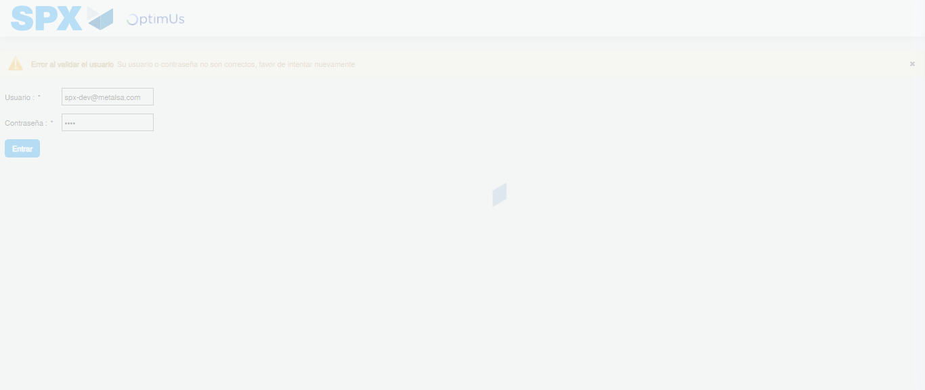Image file-name: QC_Testing-tc001_SPX_Dev5_Crear_Solicitud_Articulo_Almacen-1787863965822

Step 2 - Select to UEN and Access to Request for a New Inventory Item : UEN Correctly selected and Correct access
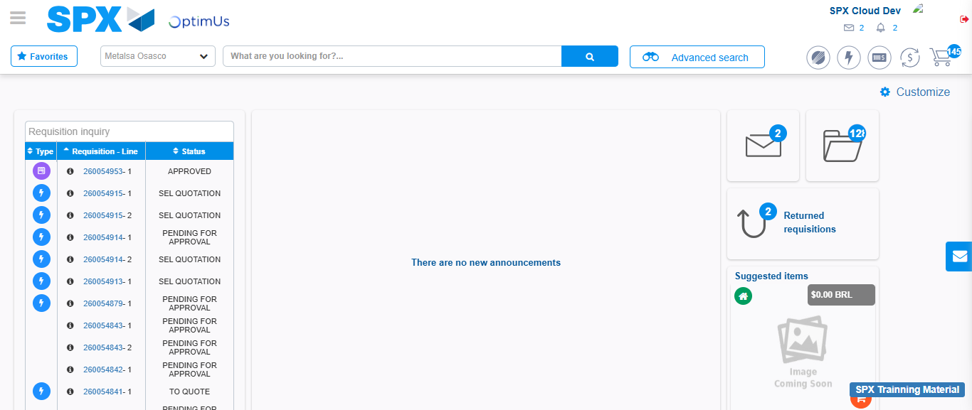Image file-name: QC_Testing-tc001_SPX_Dev5_Crear_Solicitud_Articulo_Almacen-1787863991476

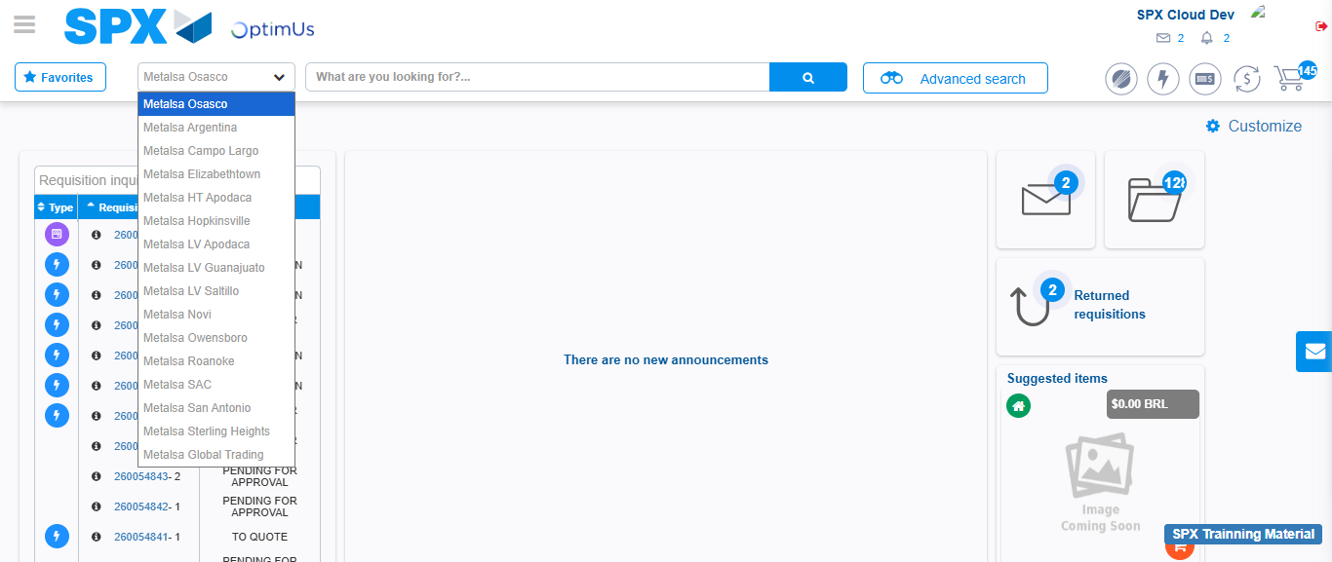Image file-name: QC_Testing-tc001_SPX_Dev5_Crear_Solicitud_Articulo_Almacen-1787863991910

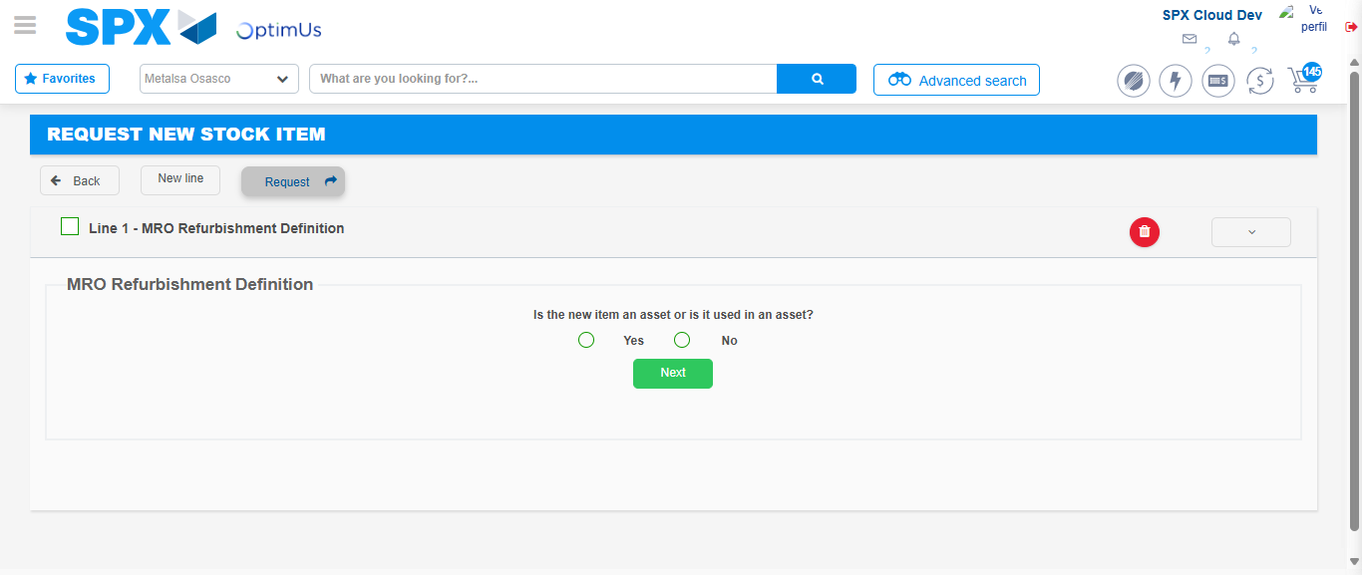Image file-name: QC_Testing-tc001_SPX_Dev5_Crear_Solicitud_Articulo_Almacen-1787864032463

Step 3 - Select options first section : Options seleted correctly
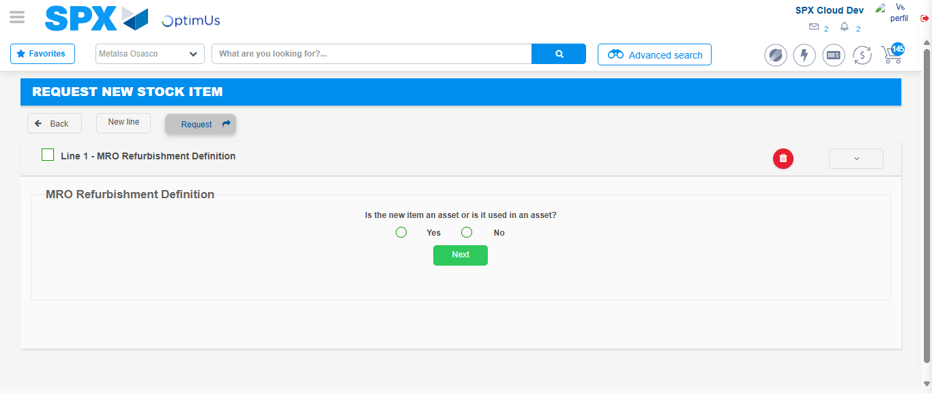Image file-name: QC_Testing-tc001_SPX_Dev5_Crear_Solicitud_Articulo_Almacen-1787864032740

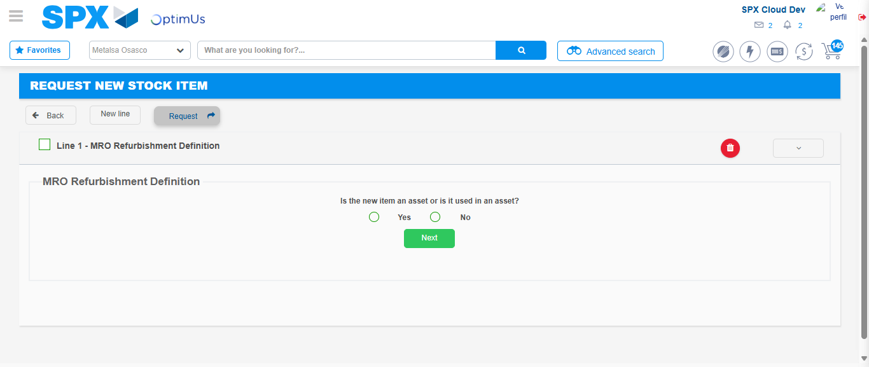Image file-name: QC_Testing-tc001_SPX_Dev5_Crear_Solicitud_Articulo_Almacen-1787864032948

Step 4 - Select options section location and position: Options seleted correctly
Image file-name: QC_Testing-tc001_SPX_Dev5_Crear_Solicitud_Articulo_Almacen-1787864032740

Image file-name: QC_Testing-tc001_SPX_Dev5_Crear_Solicitud_Articulo_Almacen-1787864032948

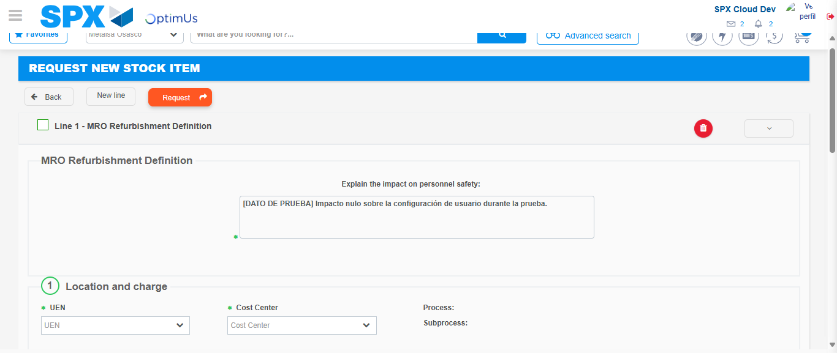Image file-name: QC_Testing-tc001_SPX_Dev5_Crear_Solicitud_Articulo_Almacen-1787864038768

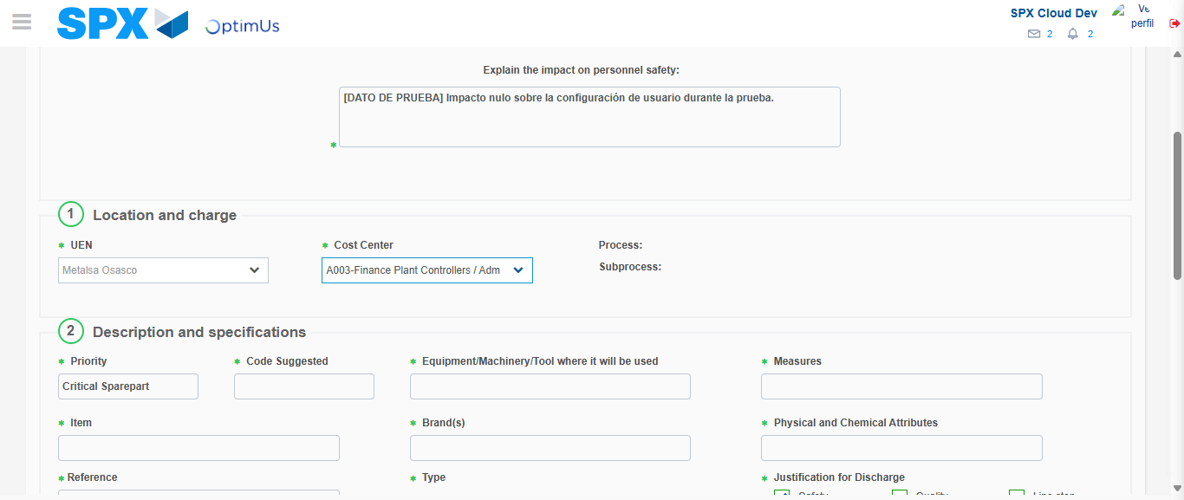Image file-name: QC_Testing-tc001_SPX_Dev5_Crear_Solicitud_Articulo_Almacen-1787864041184

Step 7 - Return to Main Page SPX : Return to Main Page SPX
Image file-name: QC_Testing-tc001_SPX_Dev5_Crear_Solicitud_Articulo_Almacen-1787863991476

Image file-name: QC_Testing-tc001_SPX_Dev5_Crear_Solicitud_Articulo_Almacen-1787863991910

Image file-name: QC_Testing-tc001_SPX_Dev5_Crear_Solicitud_Articulo_Almacen-1787864032463

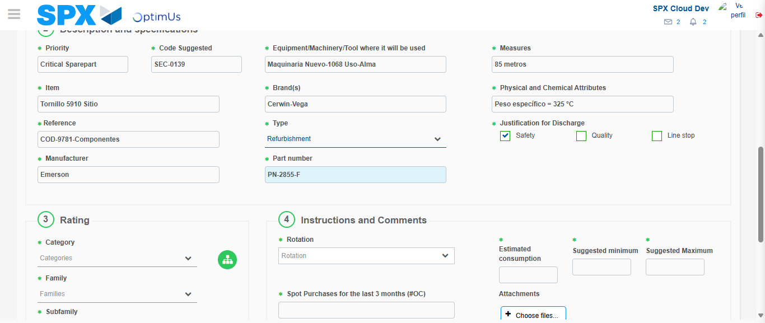Image file-name: QC_Testing-tc001_SPX_Dev5_Crear_Solicitud_Articulo_Almacen-1787864044506

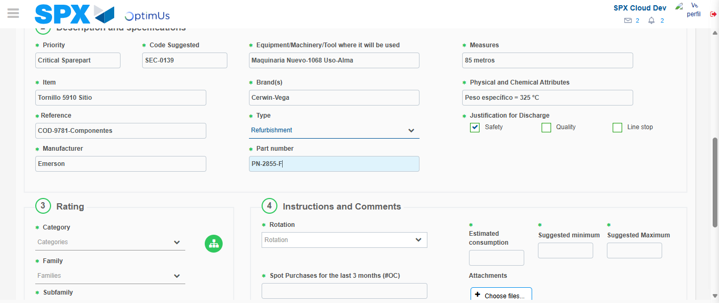Image file-name: QC_Testing-tc001_SPX_Dev5_Crear_Solicitud_Articulo_Almacen-1787864044669

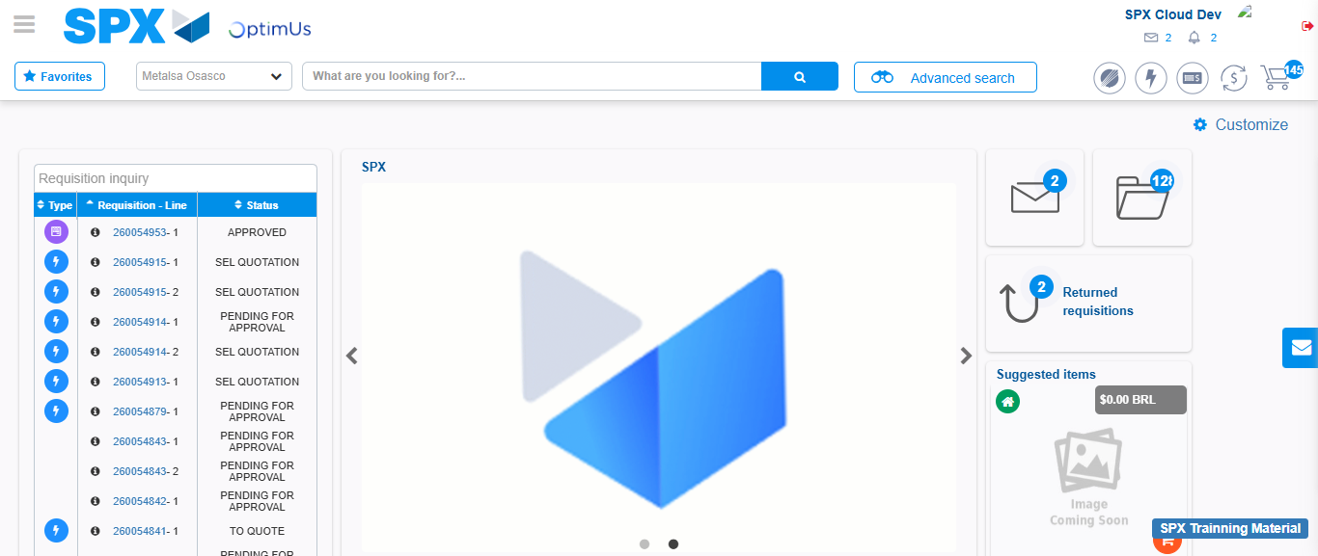Image file-name: QC_Testing-tc001_SPX_Dev5_Crear_Solicitud_Articulo_Almacen-1787864065696

Step 8 - Log Out : Log Out SPX
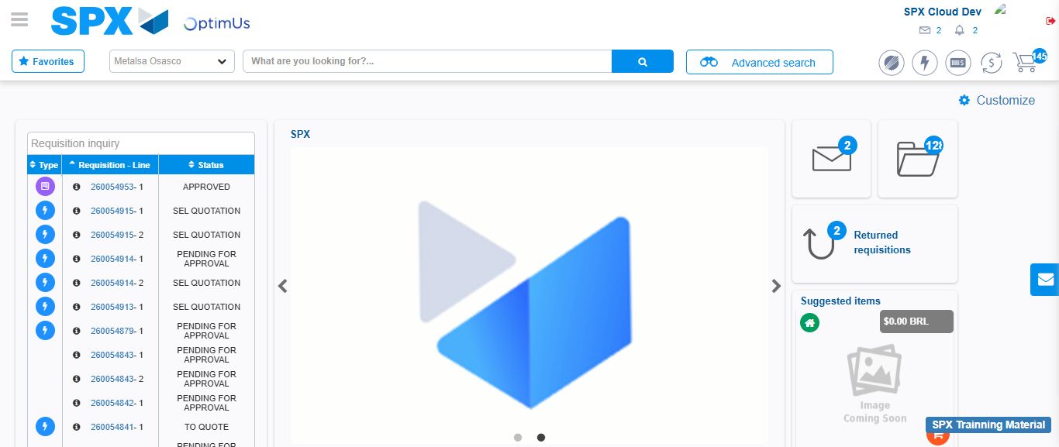Image file-name: QC_Testing-tc001_SPX_Dev5_Crear_Solicitud_Articulo_Almacen-1787864065984

